**TASK 4: Chemistry Year 11: Spectroscopic techniques:**

**Name: ________________________**

1. Consider the atomic emission spectrums below:

**[2]**

|  |  |
| --- | --- |
| Lithium | http://chemistry.bd.psu.edu/jircitano/Li.gif |
| Sodium | http://chemistry.bd.psu.edu/jircitano/Na.gif |
| Nitrogen | http://chemistry.bd.psu.edu/jircitano/N.gif |
| **UNKNOWN** | http://chemistry.bd.psu.edu/jircitano/Li.gif |

Identify the unknown element, giving reasons for your answer:

Lithium – matching emission spectrum

**2. Flame tests and gas discharge tubes:**

In these experiments, you observed different colours.

Explain how these colours occur. Use a **diagram** to support your answer

**[4 marks description, 2 marks diagram ]**

*Heating or providing energy to the compound provides energy to the sample. (1)*

*This causes electrons to move to higher energy levels. (1)*

*As the electrons drop back to the lower energy level they emit light of a characteristic energy or wavelength, which is the difference between the energy levels (2).*

***(2 marks diagram)***

Emission lines

3.

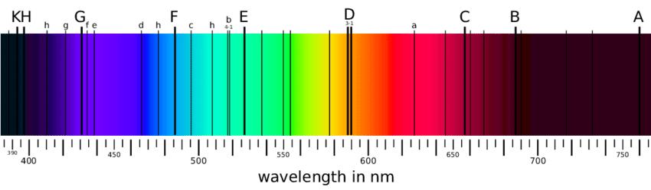

When measuring the light spectrum emitted by the sun an astronomer observes some areas of dark lines. The coloured spectrum is emitted from the main body of the sun and the dark lines occur when the light passes through the atmosphere of the sun.

Explain what is occurring and the information it gives. Use a supporting diagram (6marks)

*Light is absorbed by the sun’s atmosphere (1)*

*When light of the exact energy difference between an element’s energy level (1)occurs it is used to move an electron from a lower energy level to a higher energy level. (1)*

*Therefore, a dark line is seen at that energy difference. (1)*

*Since each element has unique energy level spacings it gives information about the elements present. (1)*

***(1 marks diagram)***

Absorption lines

To determine the concentration of Lead in a sample of water a student made standard lead solutions, absorption of each was measured. The results of these, and the absorption from a water sample are shown below:

|  |  |  |
| --- | --- | --- |
| **Sample** | **Concentration (ppm)** | **Absorbance** |
| Blank | 0∙00 | 0∙00 |
| Sample 1 | 1∙00 | 0∙17 |
| Sample 2 | 2∙00 | 0∙34 |
| Sample 3 | 3∙00 | 0∙48 |
| Sample 4 | 4∙00 | 0∙65 |
| Sample 5 | 5∙00 | 0∙83 |
| Unknown Sample | ? | 0∙53 |

* 1. Draw a calibration curve of the data, including a line of best fit. [3]



1 – data, 1 – labels, 1 – line of best fit

* 1. Use the calibration curve to estimate the concentration of lead in the unknown sample. [2]

1 – show working 1 - ~3.3ppm

4. Students are given a mixture of the following substances, construct a flowchart that details a process (with appropriate equipment) which could be used to separate and collect all substances into pure forms:

*Nickel beads, water, marble chips, copper (II) sulphate* [Note: copper (II) sulphate is soluble in water] (6 marks)

Nickel – magnet (1)

Marble chips – filter (1)

Copper (II) sulphate and water

Evaporate off Water and collect by condensation– condensation (1)

Leaving Copper (II) sulphate (1)

Sensible order (2)